 | Monthly Household Expenses and Debt Payments
LOAN NUMBER __________________________________ | # of Individuals Living in Property_________________
First Mortgage Payment
Second Mortgage Payment
Homeowner's Insurance (if non-escrowed)
Property Taxes (if non-escrowed)
Credit Cards/Installments (minimum monthly payment)
Alimony/ Child Support payments (*)
Auto - Lease payments
Auto - Insurance
Auto - Gas
HOA/Condo Fees/ Property Maintenance (*)
Mortgage payments on other properties
Food
Utilities – Electric (*)
Utilities – Gas/Heating (*)
Utilities – Water (*)
Utilities – Other (*)
Medical (*)
Entertainment (*)
Child Care (*)
Cell Phone (*)
Other (*)
Other (*)
Other (*)
Other (*)
TOTAL
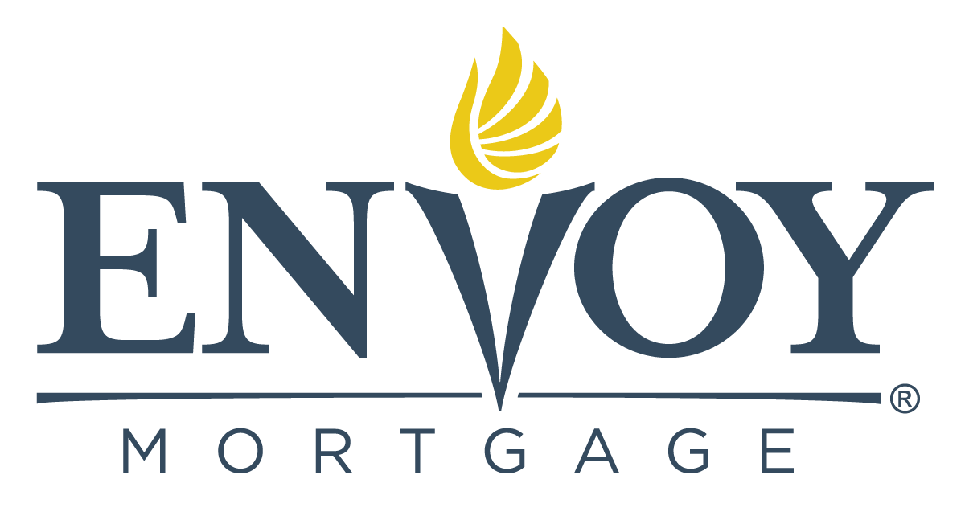
Note: This form is required to be completed and should be used in addition to the “Uniform Borrower Assistance Form” to provide detailed information regarding recurrent monthly expenses.
*In certain circumstances, Envoy may require supporting documentation relevant to your monthly expenses, i.e. copies of utility bills, cell phone bills, medical bills, alimony/child support payments, and other recurring expenses not captured on your credit report.

